 | The St Anne’s Way  Expectations for  Teaching and Learning  at St Anne’s Primary School

A Concise Guide to ‘Brain -Friendly’ Strategies for Effective Learning
Drawn from:
1, Rosenshein’s Principles of Learning
2, Education Endowment Fund (EEF) Metacognition 7 step Model
The St Annes Way – A Model for Effective Teaching and Learning
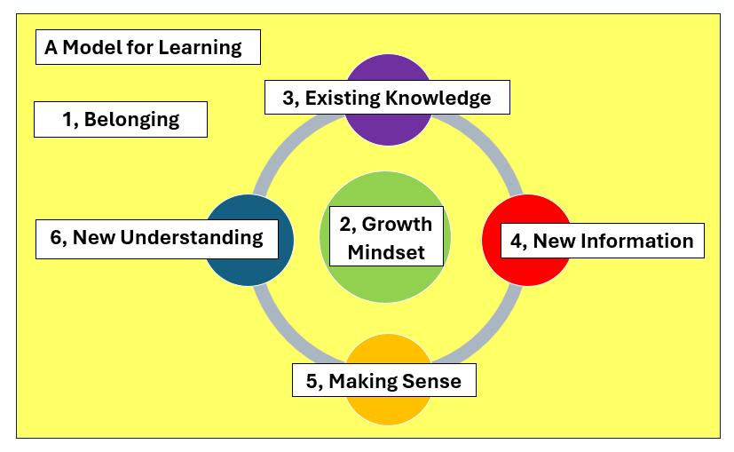
Preconditions for learning:
1, A sense of belonging is vital if children are going to feel safe, secure and trusting enough to take the risks that are associated with effective learning
2, A Growth Mindset forms the basis of effective learning – I can if I think that I can!

A Model for Learning:
3, Effective learning always builds on the secure foundation of the children’s existing knowledge
4, New or next step information is added to this
5, In a meaningful activity that challenges children to make sense of the new information for themselves
6, In a way that helps to create a new understanding

Our Model for Learning can translate into a Model for Teaching
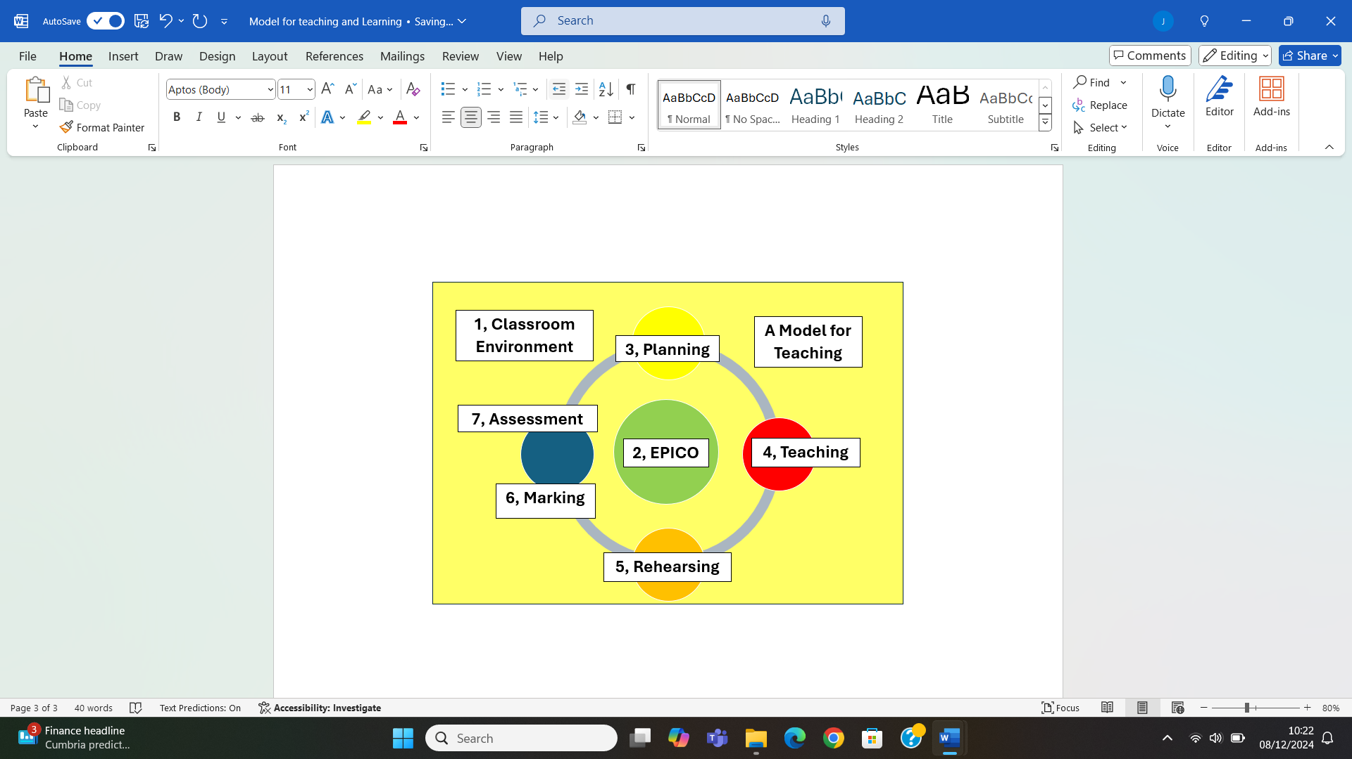
St Anne’s Model for Teaching
In this model:
- The sense of Belonging is created by establishing a positive climate for learning in which all children feel valued, understand what is expected from them and that they belong
- The strategies needed to generate a growth mindset are contained within EPICO - Engagement, Pace, Involvement, Challenge, and… Oracy – as it is through Oracy that children make sense of things for themselves.
- Each of the Stages of the model for learning can be mapped onto the model for teaching – 3, planning, 4, teaching, 5, rehearsing, 6,Marking, 7, AfL

2, Preconditions for Learning
Establishing a Positive Climate for Learning
At St Anne’s you with find classroom environments that …
- Have clear, positive, shared expectations for children’s engagement and learning supported by the consistent celebration and recognition of effort and achievement.
- Are welcoming and well-maintained and create a sense of pride, ownership and positive learning
- Provides the high-quality teaching, enriched learning opportunities and caring support needed to ensure the inclusion of all children regardless of learning styles and needs
- Are organised, tidy and promote collaboration and creativity as well as providing easy access to the support materials that all learners need to learn independently
- Provides all children with a voice to discuss their learning and actively involves them in decisions about their learning and the classroom environment.
- Sustains a supportive environment and robust pastoral care system that promotes positive students' emotional and social well-being and helps all children feel that they belong
- Promotes positive choices in behaviour through a consistently applied system of agreed expectations supported by positive rewards and a restorative justice system that supports children to reflect on the impact of their choices on others
- Promotes equality, challenges stereotyping and celebrates cultural diversity both in the curriculum and in the celebration of cultural and special events.

EPICO (Excitement, Pace, Involvement, Challenge and Oracy)
At St Anne’s Children will learn a Growth Mindset through EPICO Learning Experiences . These include…
- Engaging, high energy, positive teaching using a range of practical and visual stimuli and active learning experiences that challenge children to make sense of new learning for themselves
- Innovative lessons that contain challenge and surprise with plenty of opportunities for children develop ideas, practice oracy skills, learn new vocabulary and learn with and from each other
- Well-paced lessons that use learning time efficiently and create a positive sense of momentum and urgency in learning
- Challenge children to make sense of new learning through practical, hands-on and co-operative activities that encourage interaction with others.
- Challenge children to think hard and make secure connections with their prior knowledge to establish firm foundations for new learning
- Use a range of no-hands up questioning and other ‘talk for learning’ activities that challenge children to work together to order, develop and apply their thinking
- Challenge children to present their new learning in innovative, practical and creating ways (including drama and drawing)
- Ensuring that immediate feedback from all adults recognises and validates achievement and challenges children to refine and develop their thinking and understanding.

3, Expectations for Quality First Teaching
At St Anne’s you will see planning that …
- Follows identified schemes of work and agreed planning structures/formats to ensure continuity and progress
- Identifies clear learning intentions and outcomes along with learning activities matched to the L.O. to ensure clarity in learning
- Identifies how key learning is to be introduced, modelled and rehearsed using the ‘I do, We do, You’ approach to increase confidence and independence
- Identifies the scaffolds and practical learning resources needed to adapt learning activities to enable all children to meet identified learning objectives
- Identifies key questions and talk-based activities that can be used to check understanding and prompt deeper thinking.
- Includes a range of active learning activities that engage learning, promote oracy and challenge children to make sense of new learning for themselves
- Is annotated using evaluation information including identifying additional support and target learning to ensure the best progress of all children.
At St Anne’s you will see teaching that …
- Starts with a recap of prior learning to establish secure foundations for new learning
- Includes explicit strategy instruction chunked into sections appropriate for age/ stage of learners to avoid cognitive overload – concentration spans + chronological age +1
- Has a balance of 70% pupil talk: 30% adult talk and has planned opportunities for children to talk together to make sense of new learning for themselves
- regularly uses ‘no hands up’ questioning to engage all children and check understanding, consolidate learning and challenge further thinking
- Starts with practical examples or materials to establish a secure foundation for new understanding before moving to more practical applications
- Provides clear modelling of strategies including of the thinking process to help learners understanding of the metacognitive process
- Uses the ‘I do, We do, You do’ approach used to increase learners’ independence as their confidence grows
At St Anne’s you will see Learning Activities that …
- Are creative, engaging and challenge all learners to collaborate and talk about their learning to make sense of new learning for themselves
- Are adapted to the needs of all learners using a range of scaffolds that support all children to learn independently
- Reinforce high expectations of pupil engagement and outcomes
- Uses open-ended questioning to challenge children to clarify and consolidate their learning
- Provides Targeted support from all adults to help identified children catch up and keep up
- Reduces the level of support provided as children become more confident and independent in their learning
- Include a variety of VAK outcomes that encourage children to display their understanding in a variety of creative ways
At St Anne’s you will see Marking that …
- Is relevant to the learning task and uses a range of approaches (appropriate to the activity)
- Is undertaken either during or after the lesson and involves all adults working in the classroom
- Is timely and regular thus recognising and validating children’s effort and achievement against identified learning objectives
- Uses Peer and Self-Marking to Involve students in evaluating their own or peers' work to deepen understanding.
- Celebrates success by highlighting specific strengths and sets targets for improvement
- Challenges common or regular misconceptions using marking codes where appropriate
- Is followed up with children being given the opportunity / support needed to improve their learning

At St Anne’s you will see Assessment for Learning that …
- Evaluates (and records) the in-lesson progress of all children (especially SEN and focus children) and uses this information to inform next steps in learning for all children
- Identifies common misconceptions that need to be addressed before learning continues
- Is used to set targets, target support and identify next steps in learning annotated on planning
- Uses a range of summative assessment in the core subjects to validate formative assessments and identify potential gaps in learning.
- Evaluates, records and reports pupil progress against age related expectations and uses this information to identify focus children
- Is used as the basis of target setting and additional interventions/ support to help focus children
- Is used as the basis of reporting to ‘parents to help them understand the progress their child is making and what they could do to accelerate progress

