Catholic life of St Anne’s School – Autumn 1
Start of year Mass | Y6 led our first Mass of the new school year, reading the scripture and writing the Prayers of the Faithful; asking God to help us all do our best and be successful this year in all that we do.
Commissioning Ceremony | In this assembly, we were all reminded about the service and leadership of inspirational people such as Pope Francis, Martin Luther King, Saint Teresa of Calcutta and of course, Jesus as the leader of Christians.  Our head girls and elected House Captains pledged their duty and service to the school as they carry out their roles of responsibility as our pupil leaders.  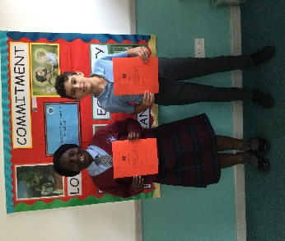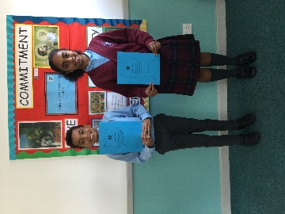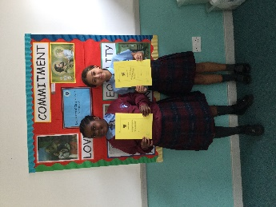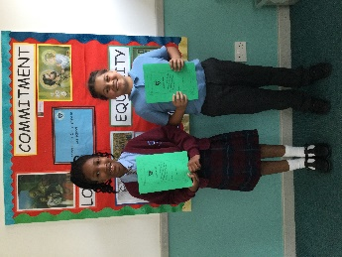
Harvest Service for EY and KS1  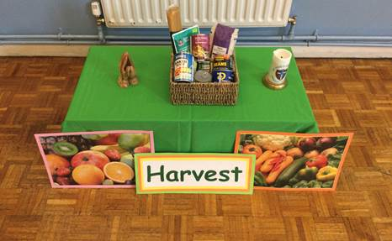 | The children sang beautifully and read the thanksgiving prayers they had written as a class to thank God for the Harvest. Fr Gerald told them about the importance of using our talents for the good of the world. Year 2 led this service. As a school we donated to the Ace of Clubs in Clapham.
Harvest Mass for KS2 | At Mass, we offered the generous donations that were received which will be gratefully received by the Ace of Clubs charity to support those in need. Children in Year 6 led the readings and each class helped us to praise and thank God for all the gifts of Harvest time.  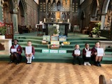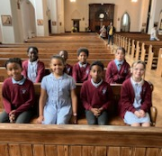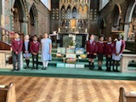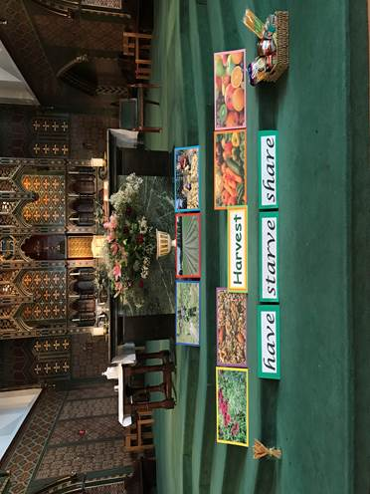
The month of the Rosary (October)  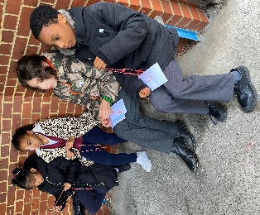 | Our Spiritual Leaders have been encouraging children to take part and supporting our praying of The Rosary during the month of October. We attended St. Anne’s and Father Gerald led a Rosary with us. The Rosary helps us to reflect on the life of Jesus and Mary his mother.  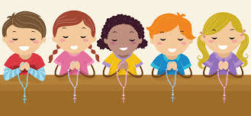
Liturgy Challenge  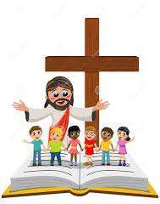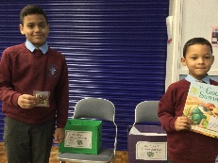 | Our weekly Liturgy Challenge helps us be prepared to think more deeply about the message of the Gospel we hear at Mass on Sunday. When children have completed the Liturgy Challenge, they put them in the correct box and a winner is chosen each week. They receive a Biblical Storybook or a set of Rosary beads.

