Catholic life of the school – Autumn 2 2025
All Saints and All Souls Assembly  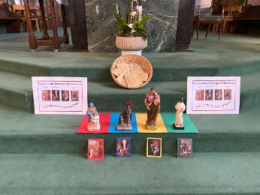 | At assembly, we thought about how our School House Saints can help s follow in the footsteps of Jesus.
The month of remembrance | We created a school Book of Remembrance where each child wrote a special prayer to remember those who have passed who were close to them.
Spiritual Leaders Network Group  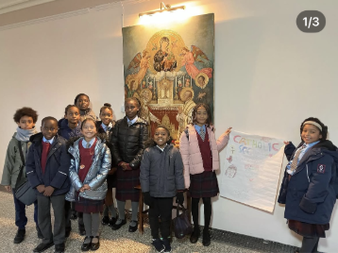 | Spiritual Leaders attended a retreat with other schools at St. Mary’s in Clapham in November. It was great to work with other local schools.
Mini Vinnies  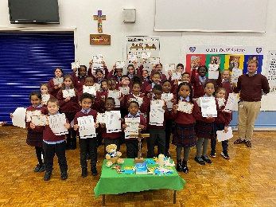 | The Mini Vinnies are the youngest members of the St Vincent de Paul Society (SVP), an international Christian voluntary organisation dedicated to tackling poverty in all its forms by providing practical assistance to people in need.
Start of Advent  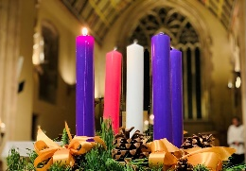 | Just after the first Sunday of Advent, as a school we lit a different candle on our advent wreath each week. We also had an Advent Mass which Year 4 led.
Nativity  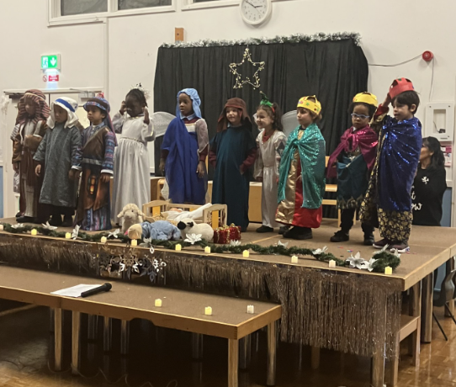 | Nursery and Reception made us smile so much our cheeks were sore! We all enjoyed their retelling of ‘Our First Nativity!’
Carol Service   | Year 5 actors and readers led us in a prayerful and reverent Carol Service.
Carol Singing | Year 3 attended the Southwark Singing Carol Service at St. George’s Cathedral.
Christingle  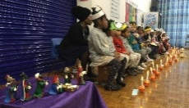 | Year 1 shared a beautiful Christingle service with the school to remind us that Jesus is the light of the world, and at Christmas we remember his goodness.

