Catholic life of St Anne’s School Newsletter– Spring 2 2026
Lent  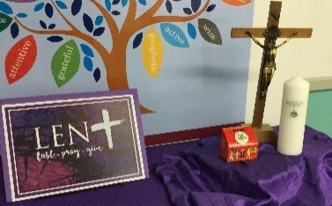 | The season of Lent started on Ash Wednesday. Purple cloth in prayer areas reminds us Lent is a time of penance.  We participated in the Big Lent Walk. KS2 went to St. George’s Cathedral and Reception and Early Years visited St. Peter’s Nursing Home.
The Big Lent Walk | We participated in the Big Lent Walk. KS2 went to St. George’s Cathedral and Reception and Early Years visited St. Peter’s Nursing Home.
Way of the Cross at St. Anne’s   | Our Spiritual Leaders led us in our own St Anne’s School Stations of the cross. Staff and pupils read some of the stations. Each class created a station of the cross.  
Spiritual Leaders  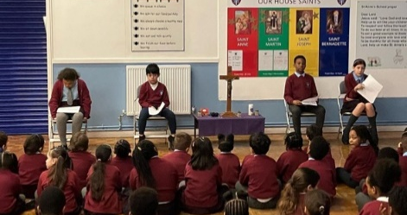 | Our team of Spiritual Leaders have been planning, preparing and leading whole-school assemblies with a focus on prayer and encouraging us to reflect on how we can live out key messages in the way we behave and act.
Stations of the Cross at St. George’s Cathedral | Year 3 attended the Station of the Cross at St. George’s Cathedrals. Other schools in the Diocese came together.
The Feast Day of St. Joseph | Year 6 attended mass on St. Joseph’s Day on the 19th of March

