Catholic life of St Anne’s School Newsletter– Spring 1 2025/26
Start of term Mass – January | As a school, we attended Mass at the start of term.  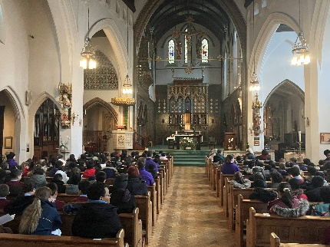
Saint Anne  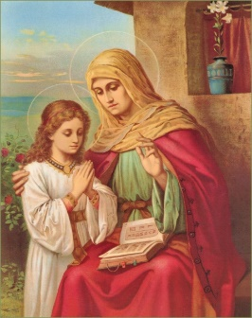 | Every Monday we say the Saint Anne prayer as a school community.
Class Masses | Each class prepared a mass (readings and Bidding Prayers) during Spring 1.
Maria Hall  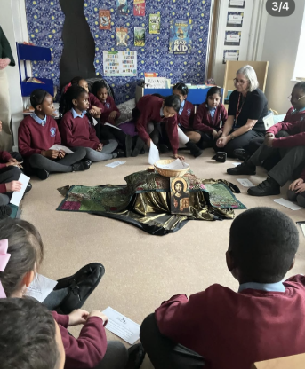 | Maria Hall who specialises in Prayer and Liturgy attended St. Anne’s on the 23^{rd of} January. She led a Prayer and Liturgy session in each class and did a CPD session with all classes.
Y4 Mass  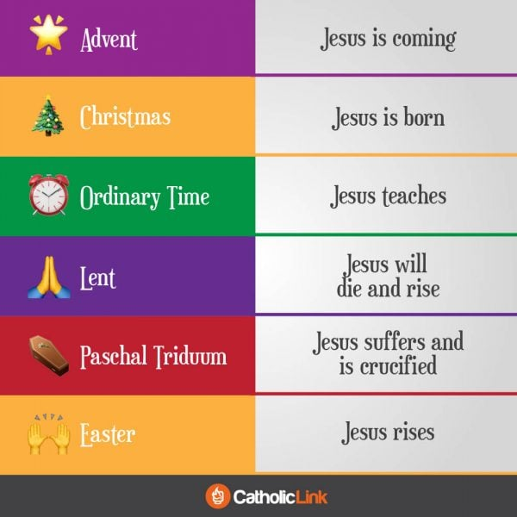 | 4CS carefully planned and led their class Mass focussing on the theme of Journeys. They have been learning about how we journey with Christ during our life and share in his way. The Church year helps us to do this too.
Spiritual Leaders | Our Spiritual Leaders continue to help us reflect on the meaning of the weekly Gospel, so that we put God’s word in to action.
Mini Vinnies | Mini Vinnies met to discuss ideas for fundraising so that we can help to support those in need, carrying out our duties of Catholic Social Teaching. Mini Vinnies have been involved in organising donations for St. Vincents Day Centre in Brixton.
Classes visiting Church  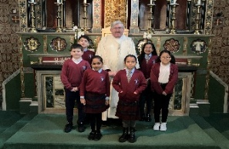 | Father Gerald has enjoyed various classes visiting the Church this half term to support their learning in RE. Thank you, Father Gerald!

